**Exercise**

* Modify the SecondRoute widget to display the image of the dice that was rolled in the main route. For example, if the main route shows a dic-3 image, the SecondRoute widget hould display the same image.
* Modify the SecondRoute widget to display the number of times the dice was rolled in the main route. For example, if the dice was rolled 5 times in the main route, the SecondRoute widget should display the number 5.

Output :

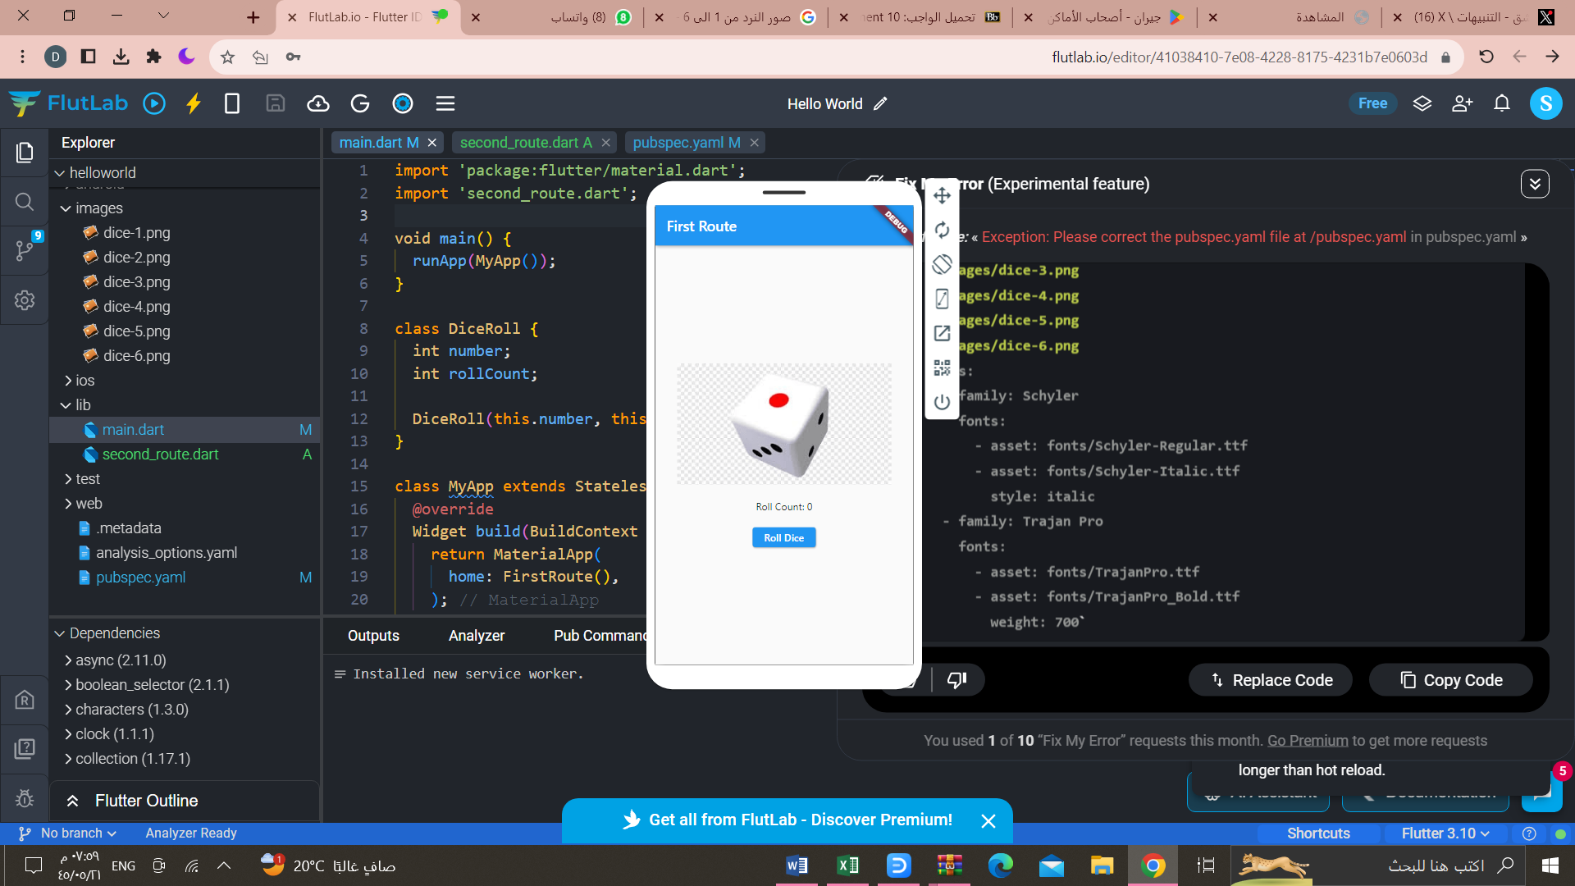

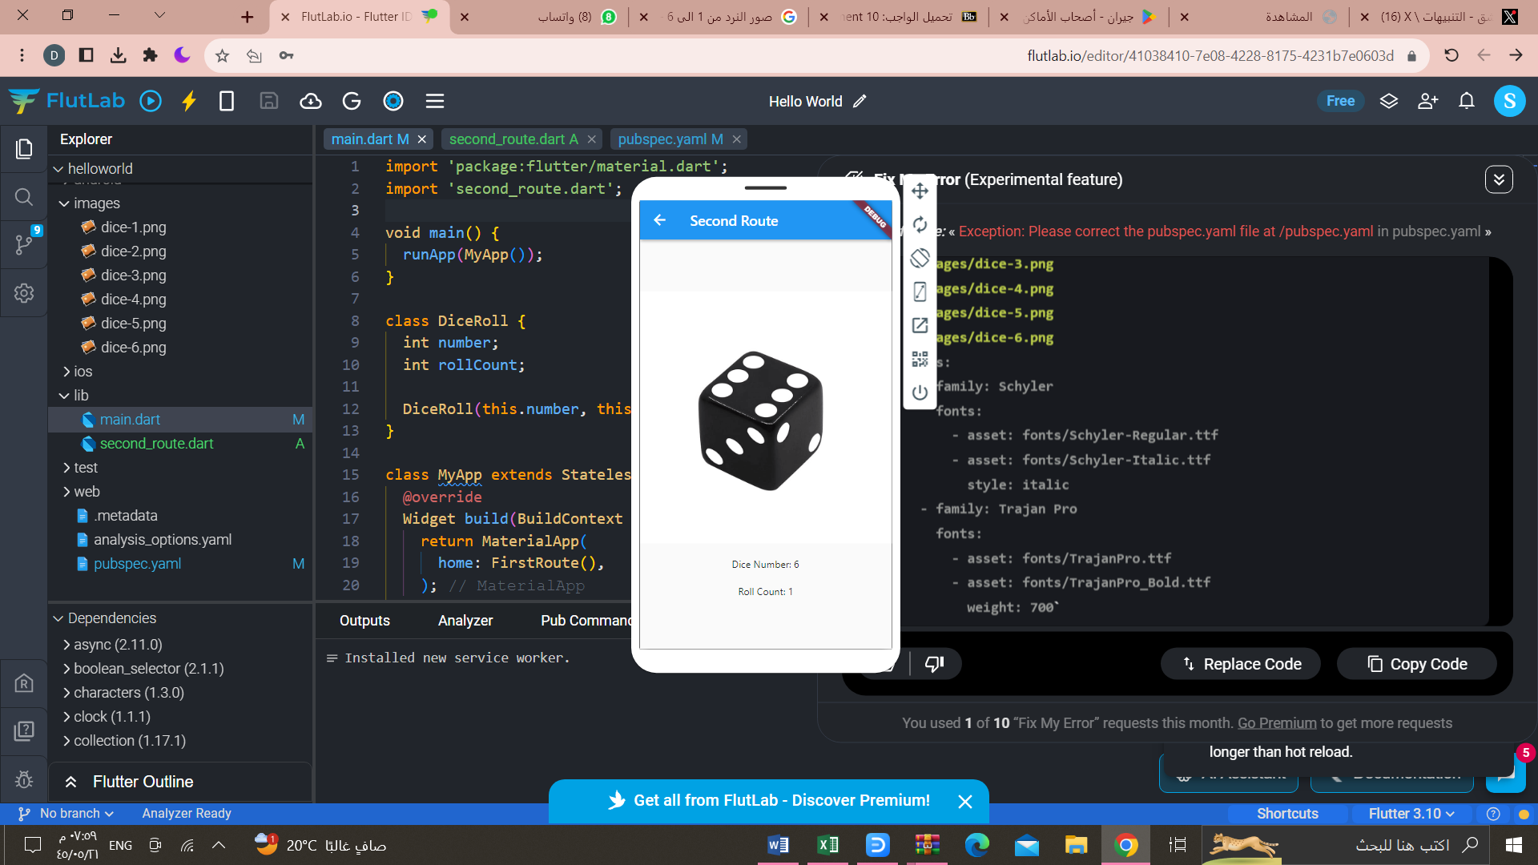

Another try :

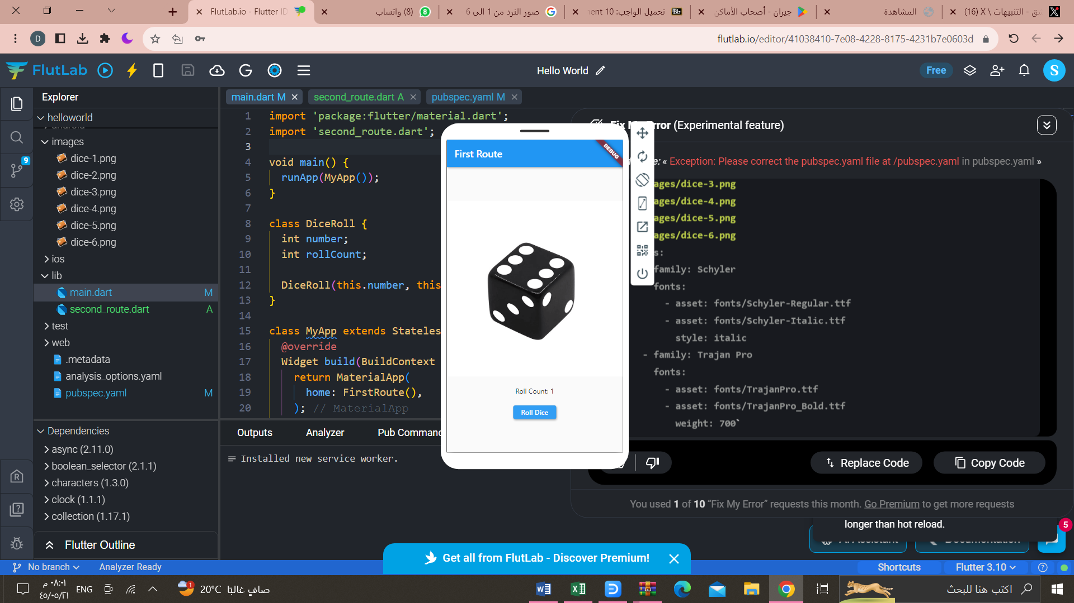

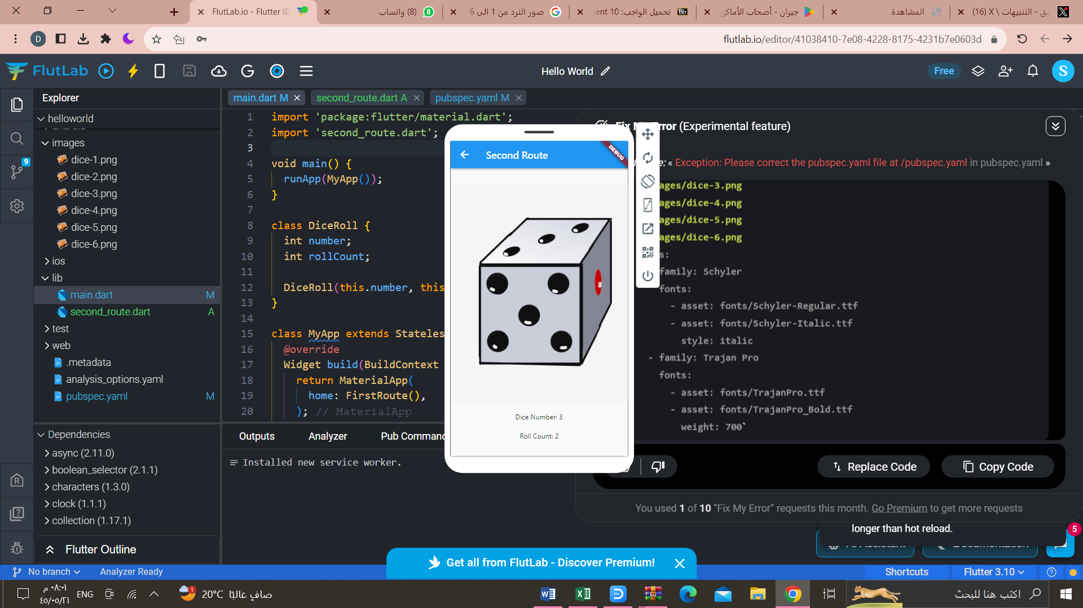

import 'package:flutter/material.dart';

import 'second_route.dart';

void main() {

runApp(MyApp());

}

class DiceRoll {

int number;

int rollCount;

DiceRoll(this.number, this.rollCount);

}

class MyApp extends StatelessWidget {

@override

Widget build(BuildContext context) {

return MaterialApp(

home: FirstRoute(),

);

}

}

class FirstRoute extends StatefulWidget {

@override

_FirstRouteState createState() => _FirstRouteState();

}

class _FirstRouteState extends State<FirstRoute> {

DiceRoll diceRoll = DiceRoll(1, 0); // Initialize diceRoll

@override

Widget build(BuildContext context) {

return Scaffold(

appBar: AppBar(

title: Text('First Route'),

),

body: Center(

child: Column(

mainAxisAlignment: MainAxisAlignment.center,

children: [

Image.asset('images/dice-${diceRoll.number}.png'),

SizedBox(height: 20),

Text('Roll Count: ${diceRoll.rollCount}'),

SizedBox(height: 20),

ElevatedButton(

onPressed: () {

setState(() {

diceRoll = DiceRoll((1 + DateTime.now().second) % 6 + 1,

diceRoll.rollCount + 1);

});

Navigator.push(

context,

MaterialPageRoute(

builder: (context) => SecondRoute(diceRoll)),

);

},

child: Text('Roll Dice'),

),

],

),

),

);

}

}

import 'package:flutter/material.dart';

import 'main.dart'; // Import the main.dart file where DiceRoll is defined

class SecondRoute extends StatelessWidget {

final DiceRoll diceRoll;

SecondRoute(this.diceRoll);

@override

Widget build(BuildContext context) {

return Scaffold(

appBar: AppBar(

title: Text('Second Route'),

),

body: Center(

child: Column(

mainAxisAlignment: MainAxisAlignment.center,

children: [

Image.asset('images/dice-${diceRoll.number}.png'),

SizedBox(height: 20),

Text('Dice Number: ${diceRoll.number}'),

SizedBox(height: 20),

Text('Roll Count: ${diceRoll.rollCount}'),

],

),

),

);

}

}